Physics 1 Unit 1 – 1D Kinematics and Error Analysis Name: ___________________________

IB 1.2 Uncertainties and Errors

**Accuracy and Precision**

1. **B. C. D.**

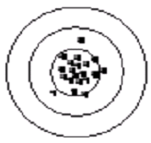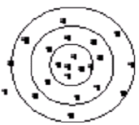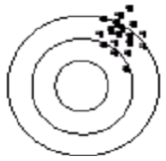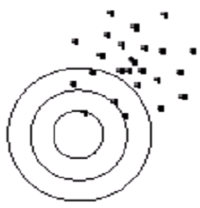

1) Which target(s) above represents measurements made with significant systematic error?

2) Which target(s) above represent measurements made with significant random uncertainty?

3) Which type of uncertainty affects the accuracy of results?

4) Which type of uncertainty affects the precision of results?

5) Which type of uncertainty can be eliminated from an experiment?

6) Which type of uncertainty can be reduced in an experiment but never eliminated?

**Default Uncertainty**

a) Determine the default uncertainty in the following measurements. b) Express the quantity in standard form including its uncertainty.

7) 43.22 m2 a) __________________ b) ________________________________

8) 3.91 kg a) __________________ b) ________________________________

9) 60,300 km a)__________________ b) ________________________________

10) 0.00260 g a)__________________ b) ________________________________

**Data Processing**

1. These are measurements for the height of the classroom door. (What is still needed for the table?) Find the average results.

|  |  |
| --- | --- |
| Trial | Height |
| 1 | 2.152 |
| 2 | 2.2 |
| 3 | 2.18 |
| 4 | 2.213 |

1. Five people measure the mass of an object. The results are 0.56 g, 0.58 g, 0.58 g, 0.55 g, 0.59 g. How would you report the measured value for the object’s mass? ( Use ½ of range to estimate the uncertainty in this data set.)
2. A student measured the final speed of a cart released from rest on an inclined plane by using a photogate system. Five trials were performed and the measured velocities were 4.43 m/s, 4.51 m/s, 4.23 m/s, 4.38 m/s, and 4.80 m/s respectively. State your best estimate of the speed of the cart including its uncertainty.
3. Find the average.
4. Find the standard deviation by hand.
5. Round the standard deviation to one sigfig. This is the uncertainty in the average.
6. Round the average so that it has the same number of decimal places as the uncertainty.
7. State your best estimate with its uncertainty and unit.

**Error Propagation**

1. To find the area of his desktop, a student took the following data. How should the area be reported?

Length of desktop: 38.4 cm ± 0.3 cm Width of desktop: 72.9 cm ± 0.3 cm

1. To find the volume of an irregular object by water displacement, the following data were taken. How should the volume of the object be reported?

Volume of water in graduated cylinder: 22.5 ml ­± 0.1 ml

Volume of water plus object: 83.7 ml ­ ± 0.1 ml

1. To find the speed of a toy car, the following data were taken. How should the speed be reported? (Hint: what formula do you need to use based on distance = rate * time?)

Distance traveled: 4.23 m ± 0.05 m Time taken: 8.7 s ± 0.2 s

1. What is the area of a circle whose radius is measured to be 6.2 cm ± 0.1 cm?
2. Adella Kutessen measured 8 floor tiles to be 2.67 m ±0.03 m long. What is the length of one floor tile?
3. The first part of a trip took 25 ± 3 s, and the second part of the trip took 17 ± 2s. How long did the whole trip take?
4. The sides of a rectangle are measured to be (4.4 ± 0.2) cm and (8.5 ± 0.3) cm. Find the area of the rectangle.
5. A car traveled 610 m ± 10 m in 32 ± 3 s. What was the speed of the car?
6. The radius of a circle is measured to be 2.4 cm ± 0.1 cm. What is the area of the circle?
7. The total resistance RT in a simple circuit will be the sum of the instrument resistance RI = 0.15 ± 0.1 Ω and the ratio of the potential V = 12 V ± 0.5 V to the current I = 0.00352 A. $R_{T}=\frac{V}{I}+R_{I}$ How is the total resistance, RT of the circuit to be reported?